Hidden Pond kennel
Stud contract
641 Dry Brook Rd.
Waverly, NY 14892
607-857-1461
David@HiddenPondLabradors.com

This contract is for the stud services from Hidden Pond Kennel and
Bitch owner's name here

HP shall mean Hidden Pond Kennel. Bitch owner shall refer to the owner of the Bitch being bred.
HP shall provide semen of good quality to have a reasonable chance of producing a litter of puppies when used in breeding dogs properly inseminated with accurate timing of ovulation determined by progesterone tests.

We do not do “natural breeding” where there is penetration of the bitch by the stud dog. We only do “side by side” breeding or shipping of chilled semen.

The bitch owner certifies that,
      - The bitch is in good health and free from brucellosis infection. That she is free from internal and external parasites. That she is current on all vaccinations including but not limited to Rabies.
      - The bitch is free from the Dilute gene and that they do not and will not sell nor produce, silver, champagne, nor any other color Labrador not officially recognized by the AKC.
      - That the bitch owner does not sell to retail outlets like pet stores.
      - That all dogs in their possession are raised and handled in a manner to insure the health and well being of the mother and her puppies.
      - That the bitch has been OFA tested for hips and elbows, and has been evaluated at fair of better for hips, and normal for elbows. A copy is required to be received by HP prior to shipment of semen.
      - That the bitch owner shall pay all shipping costs. We shall not be responsible for any delays or damage from the shipping company.

Hidden Pond Kennel Shall,
- Collect the semen and evaluate it for fitness for use in producing puppies.
- Inseminate the bitch in side be side breeding unless the owner chooses to do the breeding themselves.
- Shall prepare the semen for shipping using extender and use appropriate chilled containers for shipping of semen. If a side by side breeding is not selected. Bitch owner is responsible for the cost of the shipping and shipping containers.
- Guarantee the production of a litter from properly inseminated bitches. A litter shall be two or more live puppies born to the bitch.
- In the event no litter is produced the bitch owner shall be entitled to a second breeding at no additional charge other than the cost for containers and for the shipping costs. This shall be the only liability of HP for anything resulting or not resulting from this breeding.

The stud fee shall be $1500.00 payable prior to shipping of the semen.

The second option is to pay a $300.00 service fee prior to shipping the semen. When the litter is born the remaining $1200.00 is due within seven days of the date of the birth. If no litter is born there will be no rights to a second breeding and no additional money is due.

All shipping and packaging costs are in addition to the stud fee. Stud fees and service fees are non refundable.

Stud being used: Windswept Thunderstorm at Chinar's SR 87947506

Bitch being bred: ____

Date of breeding:

Bitch owner: Name ______________

Address ____________

City state zip code __

Phone______________

Signature _____________________________________________

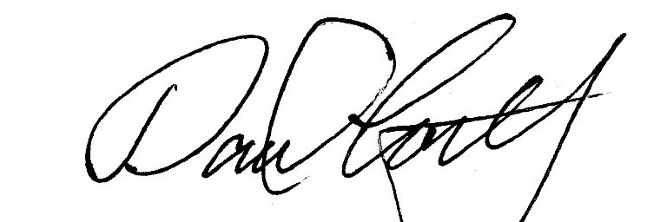
Stud owner signature______________________________________________

